The Meissner effect is a phenomenon that occurs in superconducting materials, once a supercurrent (current with 0 resistance) forms. A property of conducting materials is their London penetration depth – how far a magnetic field penetrates into the material. Materials that are superconducting expel magnetic flux fields. The currents that produce this repulsive effect, called persistent currents, do not reduce over time. This can be thought of as an infinite value for conductivity – characteristic of a superconductor. Each superconductor has its own characteristic London penetration depth (and thus, critical superconducting temperature) due to the type of material it is and its properties. At zero resistance (when temperature is decreased to superconducting levels), fields are completely expelled from the surface of the conductor. This shift to expel all magnetic fields is known as the Meissner effect. Expelling magnetic fields requires a force to be exerted on the surrounding fields – this force is enough for levitation.

There are two types of superconductors: Type I and Type II superconductors. Type I superconductors can be explained by BCS (Bardeen-Cooper-Schreiffer) theory. This theory posits that, at low temperatures, electrons can become coupled. This coupling forms a complex known as a Cooper pair. These Cooper pairs behave like bosons, and bosons at sufficiently low temperatures form Bose-Einstein condensates. The attractive force required for Cooper pairs to form is generated from the interaction between an electron and the lattice (phonons). As an electron travels through a lattice, it attracts positive charges. This increased charge density attracts another electron with opposite spin. These two electrons become correlated, and pairs continuously form and overlap to form a large condensate. This condensate has enough momentum to not be affected by kicks from resistance, superconductivity is achieved. Type II superconductors are composed of superconducting vortices in regular conductive complementary vortices. This means that Type II superconductors only experience partial Meissner effect – and can be penetrated by magnetic fields even when they are superconducting in specific regions.

For this lab, we set up an experiment mimicking the setup described in **[Figure 1]**. The voltage and current probes were used to calculate resistance, while the thermocouple was used to measure the temperature of the sample. The superconductor they were connected to was embedded in a Styrofoam dish, which was filled with liquid nitrogen. Data was collected by the integrated LabView software across a range of temperatures. BSCCO (Bismuth Strontium Calcium Copper Oxide, Br2Sr2Can-1CunO2n+4+x) and YBCO (Yttrium Barium Copper Oxide, YBa2Cu3O7-x) were both analyzed with this method. N is commonly 2, and x refers to the excess Oxygen atoms.

The critical temperatures for BSCCO and YBCO were found to be 144.2K and 96.0K, respectively **[Figures 2 and 3]**. These deviate from the literature values of 110K and 93K by 31.3% and 3.2% respectively. This is likely due to the thermocouple not accurately measuring temperature in a state of rapid cooling. Once the materials were superconducting, it was observed that levitation of magnets was possible. This is due to the partial Meissner effect exhibited by Type II superconductors repelling the magnetic fields. We know that the superconductors are Type II due to the fact that they floatation wasn’t free, but pinned in locations. This is because of the magnetic fields being trapped in the non-superconducting regions which are permeable.

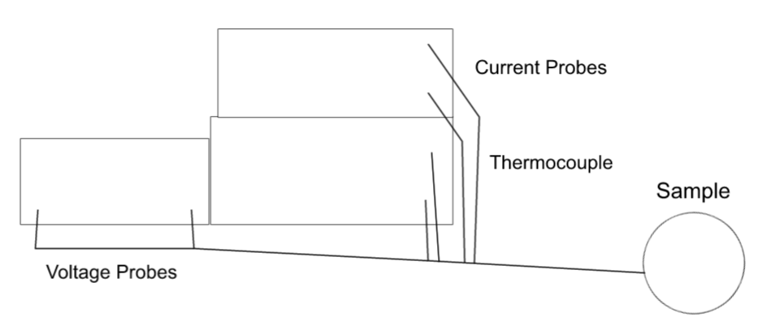

Figure 1: Our Experimental Setup

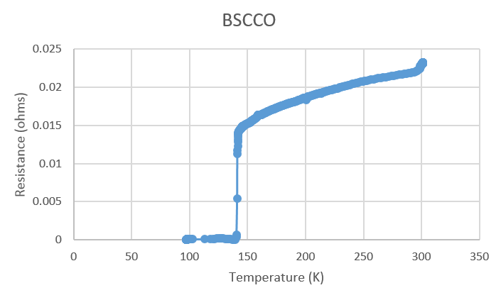

Figure 2: Resistance vs Temperature for BSCCO

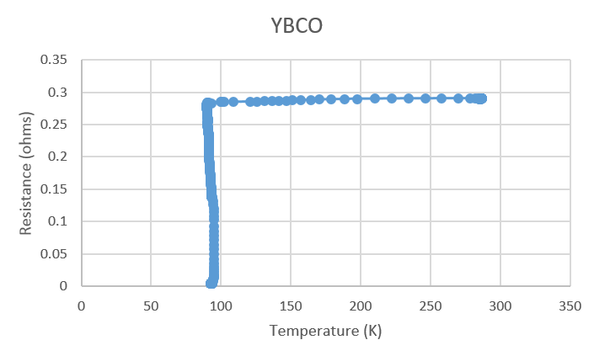

Figure 3: Resistance vs Temperature for YBCO

Sources:

1. <https://www.chemistryworld.com>
2. <https://www.global-sei.com/super/hts_e/>